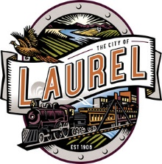 | Agenda  CITY OF LAUREL  Library Board  Tuesday, September 14, 2021  6:00 PM  720 W 3rd St, Laurel MT 59044

Public Input: Citizens may address the committee regarding any item of business that is not on the agenda. The duration for an individual speaking under Public Input is limited to three minutes. While all comments are welcome, the committee will not take action on any item not on the agenda.
1. Addressing the Board
General Items
2. Minutes
3. Correspondence
4. Circulation Report
New Business
5. New Tech Librarian
6. Conference
Old Business
7. Budget Update
8. Summer Food Program Update
9. Summer Reading updates
Other Items
10. Upcoming Items
Announcements
11. Next Regular Meeting
The City makes reasonable accommodations for any known disability that may interfere with a person’s ability to participate in this meeting. Persons needing accommodation must notify the City Clerk’s Office to make needed arrangements. To make your request known, please call 406-628-7431, Ext. 2, or write to City Clerk, PO Box 10, Laurel, MT 59044, or present your request at City Hall, 115 West First Street, Laurel, Montana.

DATES TO REMEMBER

